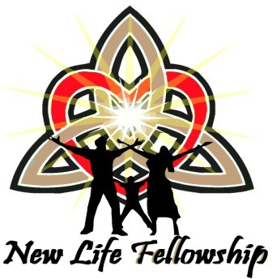
New Life Fellowship Good News Celebration Registration Form
Our 4th Annual “The Father Loves and Likes You!" Celebration 2018!
October 11th- 14th, 2018 at: Holiday Inn Oceanfront Resort Hotel
6600 Coastal Highway, Ocean City, MD. 21842

To Register for THE GOOD NEWS Celebration 2018:
Complete this form, include payment, and return to New Life Fellowship at the address below. Your Registration Cost Will COVER ALL EVENTS. Registration fees INCREASE after AUGUST 31st. Registration closes on September 28th.
For Hotel Reservations, please call Tel: 1800-837-3588 or go online to http://tinyurl.com/y7tsbwea. Updated information about the Celebration will be available on our Website (www.newlifebaltimore.org/events) AND on the Grace Communion International Website (www.gci.org/events) You may also call our Registration Coordinator at the number below. Make checks out to:

New Life Fellowship of Baltimore, Maryland
P.O. Box 1417 Owings Mills, MD 21117
Any questions can be directed to Registration Coordinator, Jamie Stewart, via phone at: 1-410-701-0810 OR Email to: jamiestewart1981@gmail.com

Full Name: Full Name: Full Name: Full Name:
Please Print

Full Name: Full Name: Full Name: Full Name:

Church/Organization:

Mailing Address: City:

State/Province: Country:
Zip/Postal Code:
Telephone: ( ) Fax: ( )

Email Address:

Registration Fees:

Adults 17 and older - $80.00:
(After August 31st - $100.00): TOTAL ADULTS:

Teens 12-16 - $50.00:
(After August 31st - $70.00): TOTAL TEENS:

Kids 4-11 - $40.00:
(After August 31st - $50.00): TOTAL KIDS:
Kids 3 and under - Free: TOTAL KIDS 3 and under:
TOTAL PAYMENT SUBMITTED: $___________
New Life Fellowship 4th Annual Good News Celebration 2018

Come Celebrate the Life and Love of God Our Father, poured out lavishly on our humanity through Jesus Christ, and in the Holy Spirit!

Come meet believing brothers and sisters from all over the world!

At: The 4th Annual “Father Loves and Likes You!" Celebration!
Event Dates: October 11, 2018 - October 14, 2018

Room Block Dates: October 10, 2018 – October 16, 2018

Last Day to Reserve rooms: September 28, 2018

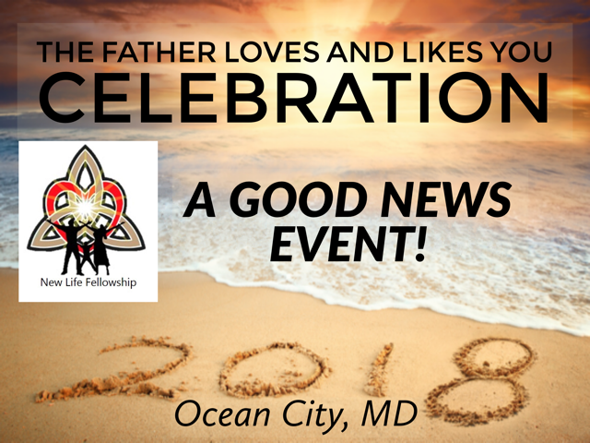

Location: Holiday Inn Oceanfront Resort Hotel 6600 Coastal Highway
Ocean City, MD 21842

Hotel Reservation: Tel: 1800-837-3588
or http://tinyurl.com/y7tsbwea
Rooms hold Six People if you book a double bedded room. (You would have 2 beds plus a sleep sofa)
The king rooms would sleep 4 comfortably. (King bed and a sleep sofa)
All these rooms come with a nice kitchenette.

New Life Fellowship of Baltimore, Maryland invites YOU to come to the beach
and celebrate God's Good News at:
"The 4th Annual Father Loves and Likes You!" Celebration 2018!
Special pricing ENDS AUGUST 31st. Registration ENDS September 28th!

Calvin Simon: Lead Pastor GCI Norfolk, VA. Timothy Brassell: Lead Pastor GCI Baltimore Richard Andrews: Asst Pastor GCI Baltimore Ann Vinson: Asst Pastor GCI Baltimore
(Check out www.newlifebaltimore.org/events for an updated “Schedule of Events” as we get closer to the event)
Let's Dance together in the GRACE, LOVE and JOY of The FATHER, SON and HOLY SPIRIT!
Don’t Miss “The Great Dance” on Saturday Night From 6:00 – 10:00 pm!
Can’t join us this year but still want to support this and future events?
GIVING ONLINE:
Go to http://newlifebaltimore.org/wptest/giving/ and click on the donate button - You'll have the option to choose a one-time gift or an automatically repeating gift. Please remember to specify your donation as "GOOD NEWS Celebration" in the Reference Section.
GIVING BY CHECK / MONEY ORDER:
Make checks out to: New Life Fellowship and write "GOOD NEWS Celebration" in the memo line and place in the offering basket at services OR mail to:
New Life Fellowship of Baltimore, Maryland
P.O. Box 1417 Owings Mills, MD 21117
~THANK YOU for your generous support!~ “Great Festival! Lots of Good News! I feel the Spirit
moving us to share” – attendee

